**UNITED REPUBLIC OF TANZANIA**

**THE TANZANIA FOOD SYSTEMS RESILIENCE**



**PROGRAM (TFSRP)**

**Draft**

**for**

**Negotiations**

**ENVIRONMENTAL**

**AND**

**SOCIAL**

**COMMITMENT PLAN (ESCP)**

**FOR THE**

**TANZANIA MAINLAND AND ZANZIBAR**

**April**

**2023**

1 | P a g e

**ENVIRONMENTAL AND SOCIAL COMMITMENT PLAN**

1. The United Republic of Tanzania (URT) will implement the Tanzania Food System Resilient Program (TRFS) with the involvement of the Ministry of Agriculture (MoA) for the Mainland Tanzania and the Ministry of Agriculture, Irrigation, Natural Resources and Livestock (MAINRL) for the Revolutionary Government of Zanzibar (RGoZ) as set out in the Financing Agreement and the Project Agreement. The International Development Association has agreed to provide financing (P179818) for the Project, as set out in the referred agreement(s).
2. The URT and the RGoZ shall ensure that the Project is carried out in accordance with the Environmental and Social Standards (ESSs) and this Environmental and Social Commitment Plan (ESCP), in a manner acceptable to the Association. The ESCP is a part of the Loan Agreement and the Project Agreement. Unless otherwise defined in this ESCP, capitalized terms used in this ESCP have the meanings ascribed to them in the referred agreement(s).
3. Without limitation to the foregoing, this ESCP sets out material measures and actions that the URT through the Ministry of Agriculture and the RGoZ through the Ministry of Agriculture, Irrigation, Natural Resources and Livestock shall carry out or cause to be carried out, including, as applicable, the timeframes of the actions and measures, institutional, staffing, training, monitoring and reporting arrangements, and grievance management. The ESCP also sets out the environmental and social (E&S) instruments that shall be adopted and implemented under the Project, all of which shall be subject to prior consultation and disclosure, consistent with the ESS, and in form and substance, and in a manner acceptable to the Association. Once adopted, said E&S instruments may be revised from time to time with prior written agreement by the Association.



1. As agreed by the Association and the URT, this ESCP will be revised from time to time if necessary, during Project implementation, to reflect adaptive management of Project changes and unforeseen circumstances or in response to Project performance. In such circumstances, the URT through the Ministry of Agriculture and the RGoZ through the Ministry of Agriculture, Irrigation, Natural Resources and Livestock and the Association agree to update the ESCP to reflect these changes through an exchange of letters signed between the Association and the Permanent Secretary, Ministry of Finance of the United Republic of Tanzania. The United Republic of Tanzania (URT) and the Revolutionary Government of Zanzibar (RGoZ) shall promptly disclose the updated ESCP.

2 | P a g e

**MATERIAL MEASURES AND ACTIONS TIMEFRAME RESPONSIBLE ENTITY MONITORING AND REPORTING**

# A REGULAR REPORTING

Prepare and submit to the Association regular monitoring reports on the environmental, Quarterly throughout project Project Management social, health and safety (ESHS) performance of the Project, including but not limited to implementation Team (PMT), the implementation of the ESCP, status of preparation and implementation of E&S instruments required under the ESCP, stakeholder engagement activities, and functioning of the grievance mechanism(s) [specify other aspects that the reporting would need to consider, as relevant].



# B INCIDENTS AND ACCIDENTS

Promptly notify the Association of any incident or accident related to the Project which Immediately, and no later than 48 hours Project Coordination has, or is likely to have, a significant adverse effect on the environment, the affected after taking knowledge about such Unit (PCU) & MAINRL communities, the public or workers, including, inter alia, cases of sexual exploitation and accidents or incidents, report to the Task abuse (SEA), sexual harassment (SH), and accidents that result in death, serious or Team Leader of the Association.

multiple injury. Provide sufficient detail regarding the scope, severity, and possible

causes of the incident or accident, indicating immediate measures taken or that are Send to the WB Root Cause Analysis and planned to be taken to address it, and any information provided by any contractor corrective actions report for

and/or supervising firm, as appropriate. accident/incidents (not later than 10 days

after the accident/incident

Subsequently, at the Association’s request, prepare a report on the incident or accident and propose any measures to address it and prevent its recurrence.

## C CONTRACTORS’ MONTHLY REPORTS - ZANZIBAR

Require contractors and supervising firms to provide monthly monitoring reports on ESHS performance in accordance with the metrics specified in the respective bidding documents and contracts and submit such reports to the Association.

Contractors for the rehabilitation of irrigation infrastructure and other related activities Contractor’s Monthly and Quarterly- Contractors will submit monthly and quarterly progress and monitoring reports on Environmental, throughout the project implementation

Social, Health and Safety (ESHS) performance to TFSRP – Zanzibar and to the submitted to the Association upon request MAINRL

Association upon request

Contractor’s reports will be submitted to TFSRP and to the Association upon request as per the Association’s requirements and format in accordance with the metrics specified in the respective bidding documents and contracts

## ESS 1: ASSESSMENT AND MANAGEMENT OF ENVIRONMENTAL AND SOCIAL RISKS AND IMPACTS

### 1.1 ORGANIZATIONAL STRUCTURE

Establish and maintain qualified staff and resources to support management of ESHS By effectiveness PMT risks and impacts of the Project including ESHS team **(**OHS, biodiversity as applicable) for

ESHS management that are relevant, if any, e.g., a health and safety specialist, an Maintain throughout Project environmental specialist, a social specialist, and establishment of coordination implementation mechanism on ESHS matters.

1.2 **ENVIRONMENTAL AND SOCIAL INSTRUMENTS - ZANZIBAR** Adopt the ESMP prior to relevant PCU

Adopt and implement an Environmental and Social Management Framework (ESMF) contractors bidding phase and for the Project and where needed, an Environmental and Social Management Plan thereafter implement the ESMP PMT

(ESMP), consistent with the relevant ESSs’ throughout project implementation. MAINRL

1.3  **MANAGEMENT OF CONTRACTORS -ZANZIBAR**  Incorporate the relevant aspects of the ESCP, including, inter alia, the relevant E&S As part of the preparation of procurement instruments, the Labor Management Procedures, and code of conduct, into the ESHS documents and respective contracts.

specifications of the procurement documents and contracts with contractors and PCU supervising firms. Thereafter ensure that the contractors and supervising firms comply

and cause subcontractors to comply with the ESHS specifications of their respective Throughout project implementation PMT MAINRL contracts.

### 1.4 TECHNICAL ASSISTANCE – ZANZIBAR

Ensure that the consultancies, studies (including feasibility studies, if applicable), service Throughout Project implementation. PMT MAINRL providers, capacity building, training, and any other technical assistance activities under the Project are carried out in accordance with terms of reference acceptable to the Association, that are consistent with the ESSs. Thereafter ensure that the outputs of such activities comply with the terms of reference. **ESS 2: LABOR AND WORKING CONDITIONS**



2.1 **LABOR MANAGEMENT PROCEDURES – ZANZIBAR** The LMP will be prepared after project

effectiveness and prior to any works.

MAINRL

Adopt and implement the Labor Management Procedures (LMP) for the Project, To be implemented throughout project

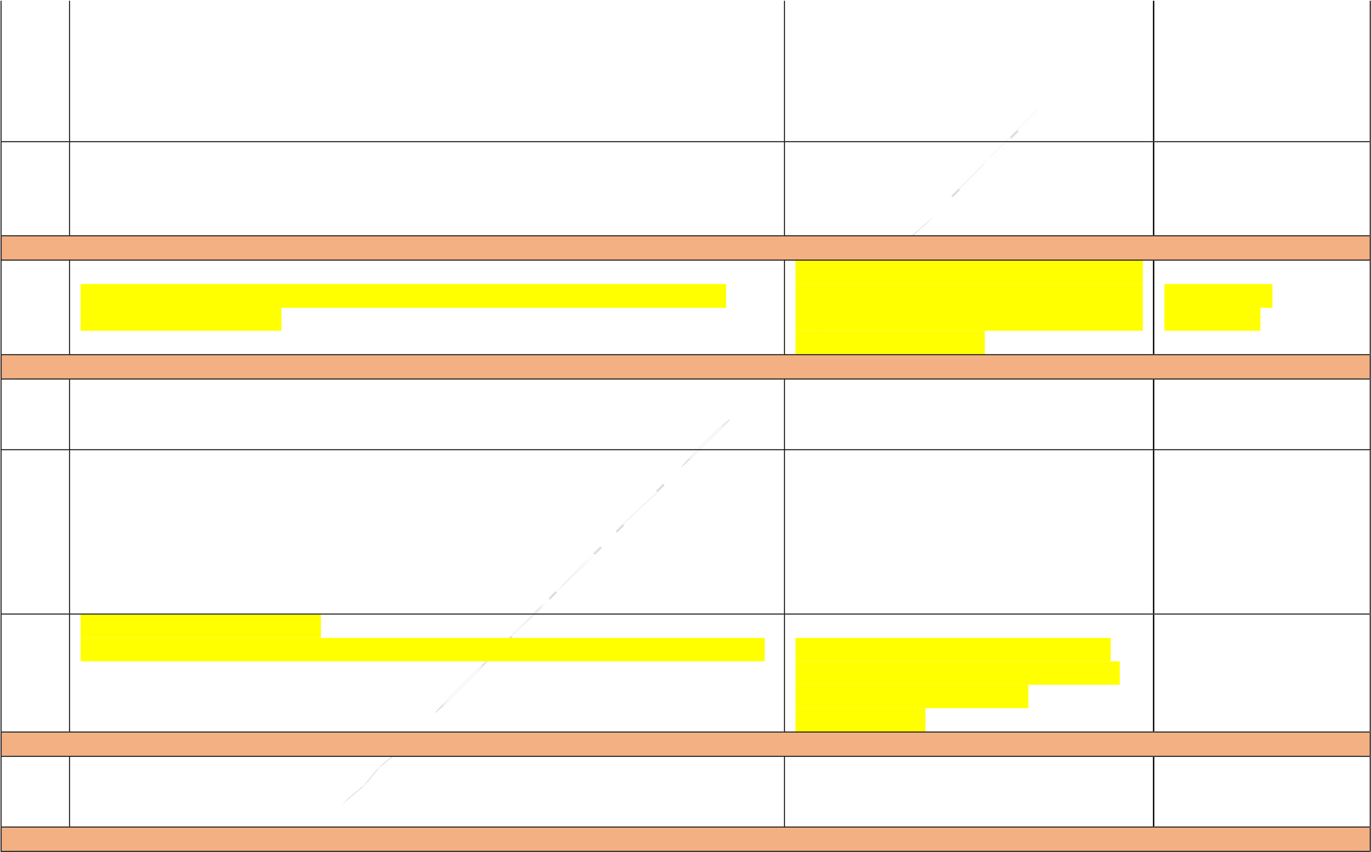including, inter alia, provisions on working conditions, management of workers implementation. PCU relationships, occupational health and safety (including personal protective equipment, and emergency preparedness and response), code of conduct (including relating to SEA and SH), forced labor, child labor, grievance arrangements for Project workers, and applicable requirements for contractors, subcontractors, and supervising firms.

2.2 **GRIEVANCE MECHANISM FOR PROJECT WORKERS - ZANZIBAR** Workers’ Grievance mechanism will be MAINRL through the

Establish and operate a grievance mechanism for Project workers, as described in the established prior to engaging Project PCU

LMP and consistent with ESS2. workers and maintained operational

throughout Project implementation. Contractors

## ESS 3: RESOURCE EFFICIENCY AND POLLUTION PREVENTION AND MANAGEMENT

3.1 ESMPs shall be adopted prior to initiating

ESMP(s) to be developed shall incorporate waste management and integrated pest activities that could lead to waste generation PMT MAINRL

management procedures. and shall be implemented throughout Contractors

Project implementation.

## ESS 4: COMMUNITY HEALTH AND SAFETY

4.1 **TRAFFIC AND ROAD SAFETY -ZANZIBAR** Same timeframe as for the adoption and PMT MAINRL

Incorporate measures to manage traffic and road safety risks as required in the ESMP to implementation of the ESMP. Contractor be prepared under EES 1 action 1.2 above.

### 4.2 COMMUNITY HEALTH AND SAFETY

Assess and manage specific risks and impacts to the community arising from Project Same timeframe for the ESMP (prior to PMT MAINRL activities including, inter alia, spread of diseases (such as HIV/AIDS) especially during relevant contractors’ bidding phase) and to Contractors construction/rehabilitation phase of sub-projects as well as construction workers and be implemented throughout project community exposure to COVID-19, behavior of project workers, risks of labor influx, etc. implementation

and include mitigation measures in the ESMPs to be prepared in accordance with the ESMF.

### 4.3 SEA AND SH RISKS - ZANZIBAR

Incorporate SEA/SE/GBV mitigation measures as part of the ESMF and ESMPs applicable Apply the GBV/SEA/SH Action mitigation PMT MAINRL

measures prior to commencement of civil

works and throughout Project implementation.

## ESS 8: CULTURAL HERITAGE

8.1 **CHANCE** **FINDS** During project implementation as part of MAINRL- PMT: PCU

Describe and implement the chance finds procedures, as part of the ESMP of the Project. ESMP and thereafter be implemented throughout project implementation.

## ESS 10: STAKEHOLDER ENGAGEMENT AND INFORMATION DISCLOSURE

10.1 **STAKEHOLDER ENGAGEMENT PLAN PREPARATION AND IMPLEMENTATION –**

# MAINLAND AND ZANZIBAR

Adopt the SEP prior to appraisal and MAINRL

Adopt and implement a Stakeholder Engagement Plan (SEP) for the Project, consistent thereafter implement the SEP throughout PMT with ESS10, which shall include measures to, inter alia, provide stakeholders with timely, Project implementation.

relevant, understandable, and accessible information, and consult with them in a MoA PMT culturally appropriate manner, which is free of manipulation, interference, coercion, discrimination and intimidation.

## 10.2 PROJECT GRIEVANCE MECHANISM – MAINLAND AND ZANZIBAR

Establish, publicize, maintain, and operate an accessible grievance mechanism, to Establish the grievance mechanism prior to MAINRL receive and facilitate resolution of concerns and grievances in relation to the Project, first disbursement and thereafter maintain promptly and effectively, in a transparent manner that is culturally appropriate and and operate the mechanism throughout PMT readily accessible to all Project-affected parties, at no cost and without retribution, Project implementation.



including concerns and grievances filed anonymously, in a manner consistent with MoA PMT

ESS10.

The grievance mechanism shall be equipped to receive, register, and facilitate the resolution of SEA/SH complaints, including through the referral of survivors to relevant gender-based violence service providers, all in a safe, confidential, and survivor-centered manner.

## CAPACITY SUPPORT

CS1 Training to be provided to PMT staff, contractors, consultants, laborers, project The trainings should be conducted as part of MAINRL through the PCU workers, communities and vulnerable women groups include but not limited to: Project preparation and on biannual basis

during project implementation.MoA Mainland through

* Association ESF the PMT
* WBG ESG Guidelines
* Implementation of ESMF
* Stakeholder mapping and engagement
* Operational Aspects of Grievance Management
* Specific aspects of environmental and social assessment and management

(such as pesticide management, resource efficiency, biodiversity. etc.)

* Emergency preparedness and response
* Community health and safety (including traffic and road safety, mitigation measures related to communicable diseases)
* Vulnerable People and vulnerability
* Sensitization to project areas communities and binding norms



•

GBV/SEA/SH risk management

•

Occupational health and safety

•

Training on the gender inclusion action plan

•

Chance

find

s

procedure

CS2

Develop and deliver training for Project workers on

occupational health and safety

including on emergency prevention and preparedness and response arrangements to

emergency situations.

Throughout Project implementation

MAINRL

through the P

MT

MoA through

the P

MT